Annex A

Breakdown of Household Energy Consumption
Across All Housing Types

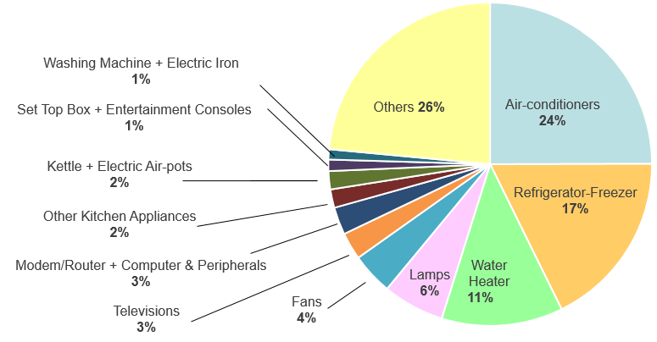

Source: Household Energy Consumption Study 2017

Annex B

MEPS for Incandescent, CFLi & LED bulbs

Table 1: Current MEPS for Incandescent, CFLi & LED bulbs
Type of Lamps* | Wattage (W) | MEPS Cut-off Levels
Incandescent | 25 - 200 | P_{max} = 0.8 x (0.88$√$φ + 0.049φ)
Compact fluorescent lamps with integrated ballast (CFLi) | ≤ 60 | P_{max} = 0.24$√$φ + 0.0103φ
LED Bulbs | ≤ 60
Covered CFLi | ≤ 60 | P_{max|covered CFLi} = P_{max|bare CFLi} /0.95
* Lamps with Edison screw and bayonet lamp caps, which are designed to be connected directly to the 230V A.C. mains by means of a socket or connector

P_{max} is maximum allowable power consumption
φ is light output in lumen

Table 2: Life Cycle Costs of Different Types of Lamps
Type of Lamp | Inefficient Lamp | Energy Efficient  Replacement Lamps
 | Incandescent  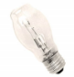  (Tungsten-halogen) | 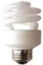  CFLi | 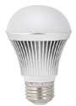  LED bulb
Annual Cost | $11.10 | $3.60 | $3.00

Annex B

Table 3: Proposed Revised MEPS Levels for Incandescent, CFLi & LED bulbs
Type of Lamps* | Wattage (W) | MEPS Cut-off Levels
Incandescent | 25 - 200 | P_{max} = 0.24$√$φ + 0.0103φ
LED Bulbs | ≤ 60
CFLi | ≤ 60
Covered CFLi | ≤ 60 | P_{max|covered CFLi} = P_{max|bare CFLi} /0.95

* Lamps with Edison screw and bayonet lamp caps, which are designed to be connected directly to the 230V A.C. mains by means of a socket or connector

P_{max} is maximum allowable power consumption
φ is light output in lumen

Annex C

Diagram 1: Energy label for lamps (to be affixed or printed on each lamp packaging)

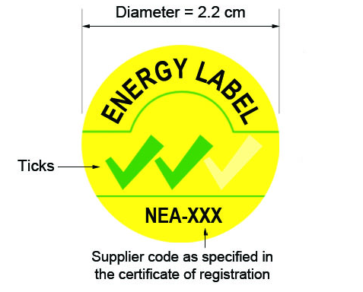

Table 4: Proposed energy rating system for CFLni (G24d lamp cap) and T8 LFL of length 0.5 – 1.5m, and their LED direct replacements
Tick rating | Rated Lamp Efficacy, η = φ/P (lm/W)
3-tick | η ≥ 135
2-tick | 110 ≤ η < 135
1-tick | η < 110  where P is the rated lamp power  - is the rated luminous flux in lumen

Lamp Types | CFLni  [Lamp cap: G24d] | LFL  [Dia. 1-inch (T8 lamp)]  0.5 – 1.5m | LED direct replacement
 | 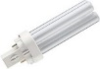 |  | 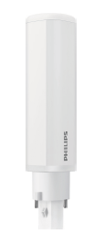  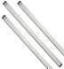
Lamp survival | 90% at 2,000h |  | 95% at 1,000h (Measured)  90% at 6,000h (Declared)
Lumen maintenance | 80% at 2,000h |  | 85% at 1,000h (Measured)  80% at 6,000h (Declared)
Table 5: Lamp survival and Lumen maintenance requirements
Annex D

Energy Efficiency of Fluorescent Lamp Ballasts

Table 6: Energy Efficiency Index (EEI) classification system
EEI Class | Description
A1 | Dimmable electronic ballasts
A2 | Electronic ballasts with reduced losses
A3 | Electronic ballasts
B1 | Magnetic ballasts with very low losses
B2 | Magnetic ballasts with low losses
C | Magnetic ballasts with moderate losses
D | Magnetic ballasts with very high losses

Table 7: Life Cycle Costs of Different Classes of Ballast
Type of Ballast | Moderate Loss  Replacement Ballasts |  | Low Loss  Replacement Ballasts
 | Class B2 Magnetic | Class B1 Magnetic | Class A3 Electronic | Class A2 Electronic
Life Cycle Cost (LCC) | $18 | $16 | $9.90 | $15.50

Annex E

Fluorescent Lamp Ballasts Not Covered Under Proposed MEPS

Fluorescent lamp ballasts that are not covered under MEPS are listed below:

- Ballasts integrated in lamps (e.g. for HID lamp),
- Ballasts used primarily in D.C. circuits,
- Ballasts not used primarily for general lighting purposes (e.g. ballasts for exit signs, laboratory, ultraviolet, industrial process applications), and
- Ballasts for luminaires that are mounted permanently in furniture which cannot be tested independently from luminaires

Annex F

Examples of Acceptable / Non-Acceptable Display of Energy Efficiency Information in Publicity Materials

Acceptable Examples
Energy Label displayed such that tick-rating is legible | No. of ticks in font same size / larger than main text
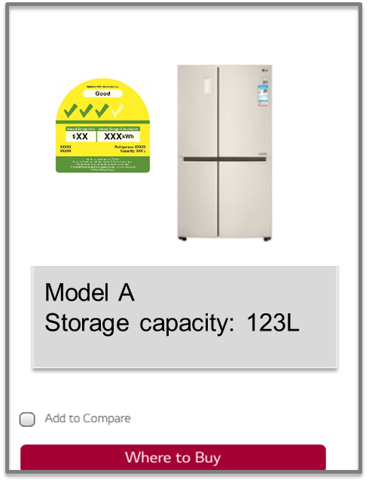 | 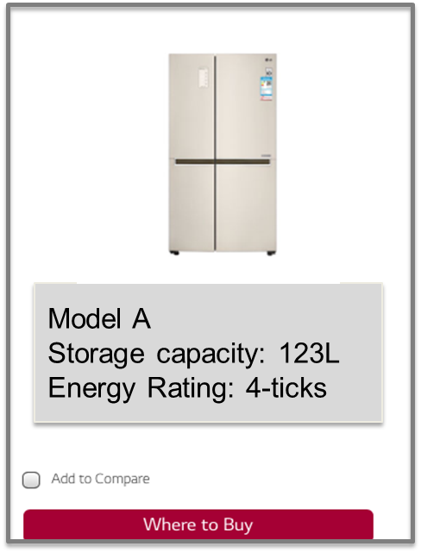

Annex F

X Unacceptable Examples
Energy Label with illegible / obstructed no. of ticks | No. of ticks in font smaller than that of other specifications
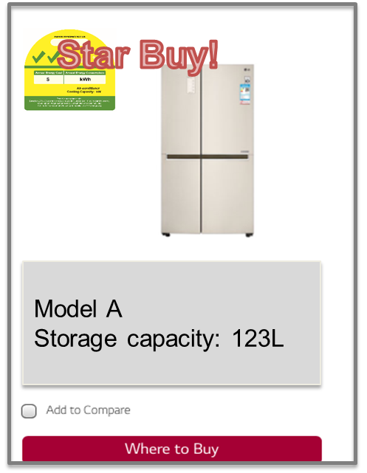 | 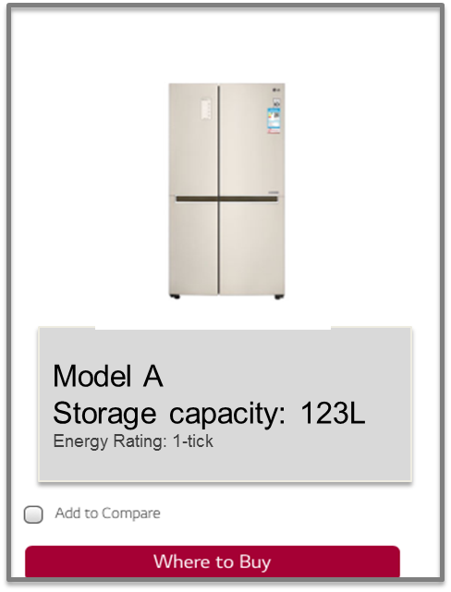

Annex G

Applicable Test Standards

Table 8
Lamp Types | CFLni  [Lamp cap: G24d] | LFL  [Dia. 1-inch (T8 lamp)]  0.5 – 1.5m |  | LED direct replacement
 | 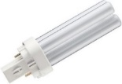
Lumen Measurement | CIE 84 |  |  | CIE S 025
Other Performance standards | IEC 60901 |  | IEC 60081 | IEC 62612*
*Only relevant clauses of IEC 62612 apply.

Upfront and energy costs are amortized to 1,000 hours, which is equivalent to around 1 year of usage, assuming 3 hours of daily usage. Energy costs are estimated based on average 2017 household electricity tariffs.
The ballasts are used with a 36W T8 tube.
Based on 10,000hr of operation which is approximately equivalent to 10 years of operation, assuming 3hr of daily usage, and 2017 average tariff including 7% GST.

