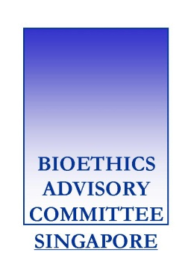
Respondent’s Form to the Bioethics Advisory Committee’s Consultation Paper on “Ethical, Legal and Social Issues Arising from Mitochondrial Genome Replacement Technology”
Please complete and send this form, together with your response, to the BAC Secretariat at bioethics_singapore@moh.gov.sg or Bioethics Advisory Committee Secretariat, Harbourfront Centre #09-66, 1 Maritime Square, Singapore 099253 by 15 June 2018.
Name : | Click or tap here to enter text
Email Address : | Click or tap here to enter text
Are you responding in your personal capacity or on behalf of your organisation?
Personal Organisation: Click or tap here to enter text
May we include your / your organisation’s response in the final report?
Yes, publish my / my organisation’s response
Yes, but anonymously
No, do not publish my / my organisation’s response
Would you like to receive a copy of the final report when it is published?
Yes, send a digital copy to:
the email address indicated above
the following email address(es) : Click or tap here to enter text
Yes, send a printed copy to the following mailing address(es):
Click or tap here to enter text
No, but notify me / my organisation of the publication at:
the email address indicated above
the following email address(es) : Click or tap here to enter text
No, and I / we also do not wish to be notified of the publication.
Please let us know how you got to know about the consultation:
Received notification by email
BAC’s website
Newspaper : Click or tap here to enter text
Others: Click or tap here to enter text
Thank you for taking the time to respond to our consultation.

